**LAB-2**

**NAME: V.TEJASWI ROLLNO : CB.EN.U4CSE19259**

**1.**List all the directories only using echo command.

2.List the calendar of September 1752 and explore.

3.Display the time of the day

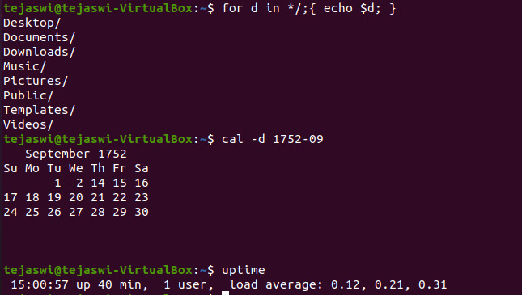

4.Create a directory by **your rollno e.g cse601**

5. Move the files to appropriate directory

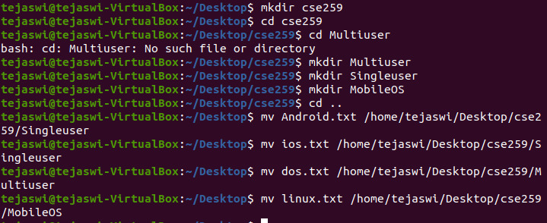

6.List all the directories and files in directory with name as your rollno

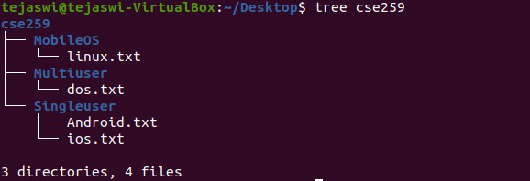

7.List the size of **all files (hiddenfiles also)**and folders in desired scale format, directories should not be displayed.

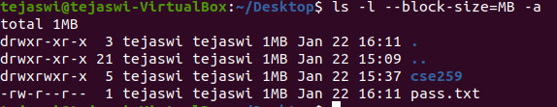

8.Change the permissions of the file DOS.txt give read and write permissions to user and group

9.List all the environment variables and display PATH

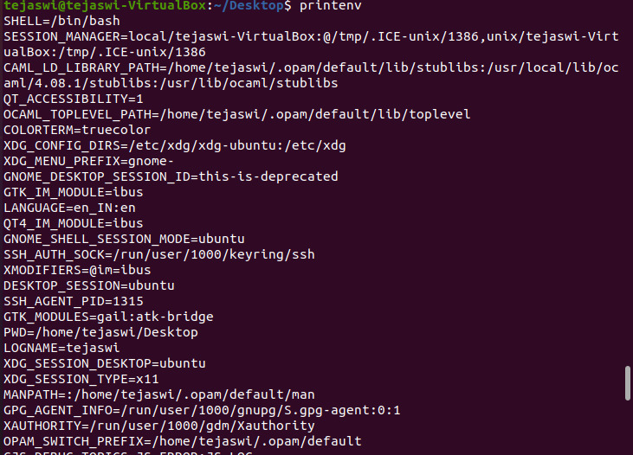



10.Change the prompt. And change it back to original prompt.

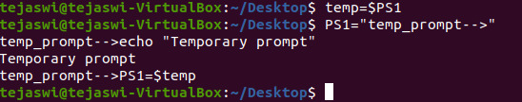

11.Copy the file /etc/passwd into your home directory.

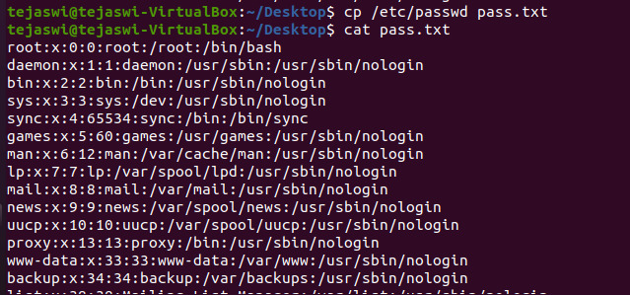

12. List the usernames and home directory from /etc/passwd in sorted order

